

Subject: Programming with Java
ASSIGNMENT No : 9
TITLE :Write a Java program to demonstrate the use of the final keyword with variables, methods, and classes.
Name:Avdhoot Mohite Class: CSE A3
PRN:25070122056 Batch:25-29
Problem Statement
Write a Java program to demonstrate the use of the final keyword with variables, methods, and classes.
Learning Objectives
To implement the final keyword with variables, methods, and classes.
Theory
The final keyword restricts modification in Java programs. A final variable cannot be reassigned after initialization. A final method cannot be overridden by subclasses, while a final class cannot be inherited. This improves security, prevents accidental modifications, and increases program reliability. Final is commonly used for constants and immutable classes.
Outcome
After completing this experiment, we learned how to use the final keyword with variables, methods, and classes in Java. We understood that a final variable cannot be reassigned, a final method cannot be overridden, and a final class cannot be inherited. This experiment helped us understand how the final keyword improves code safety, reliability, and maintainability.
Conclusion
The experiment successfully demonstrated the use of the final keyword with variables, methods, and classes in Java. It showed how final prevents unwanted modifications, supports code security, and ensures data integrity. The final keyword is an important feature of Java that helps in writing robust, reliable, and maintainable object-oriented programs.

Exercise:

1).Create a Bank Account program where account number is final and cannot be changed.
Code:
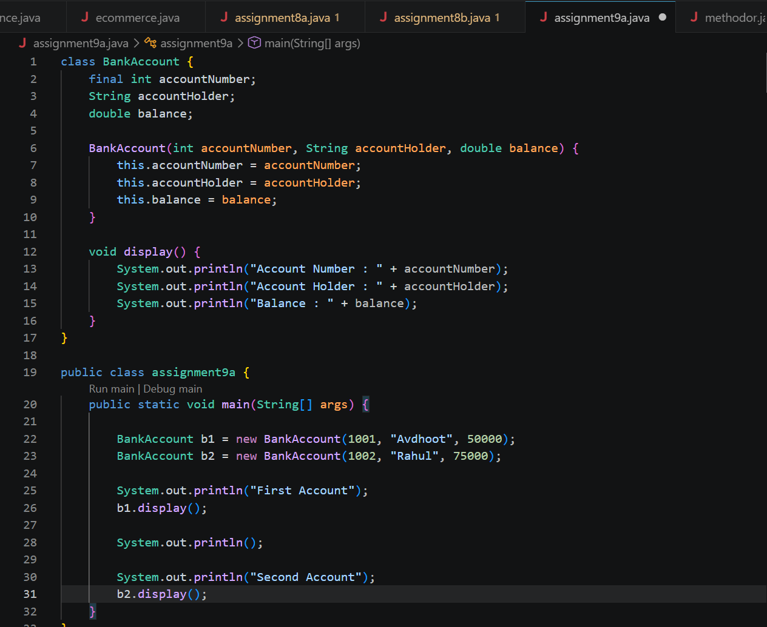

Output:
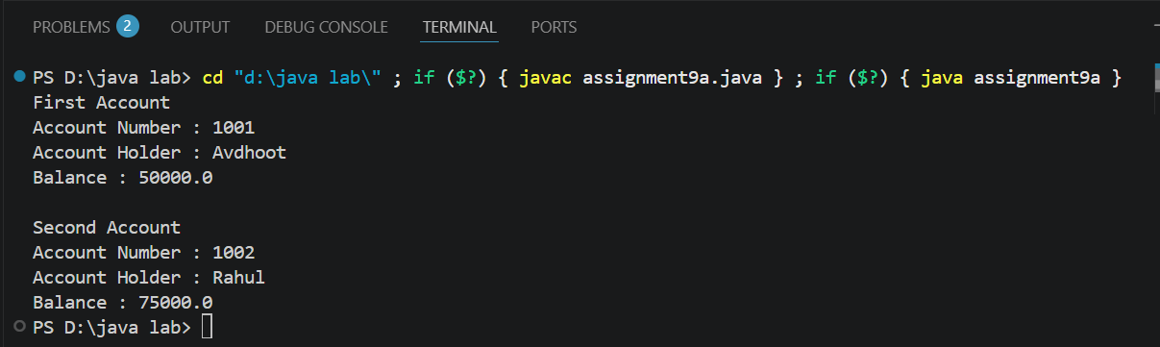

2).Create a Library Book Management program where the book ISBN is declared as final and cannot be changed once assigned. Display the book's ISBN, title, author, and price.
Code:
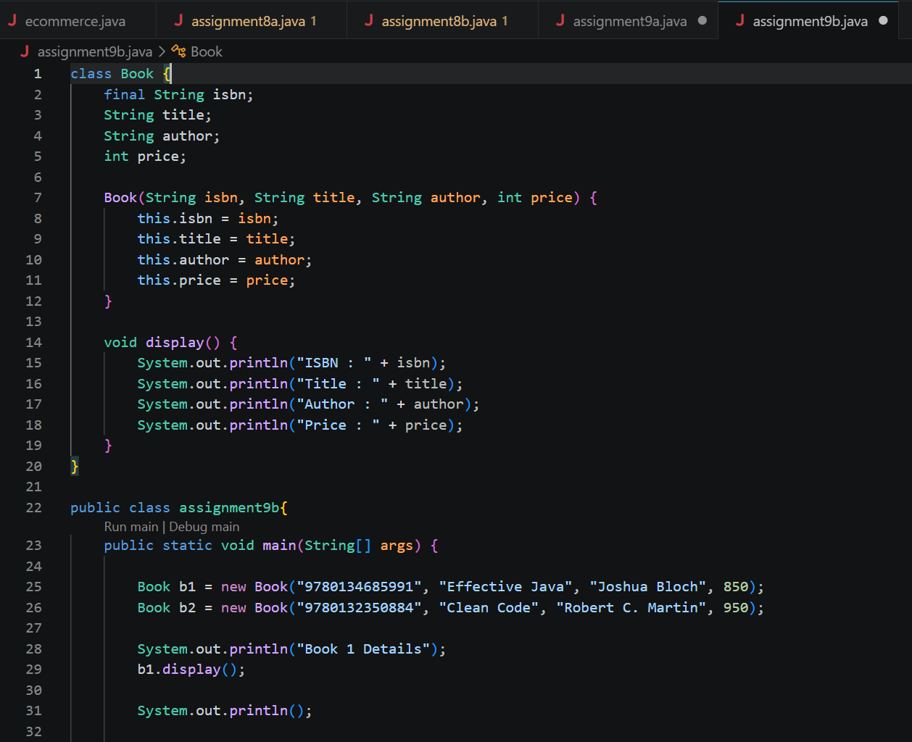
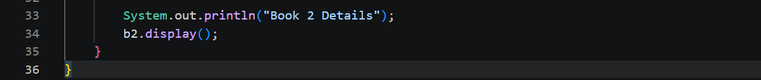

Output:
